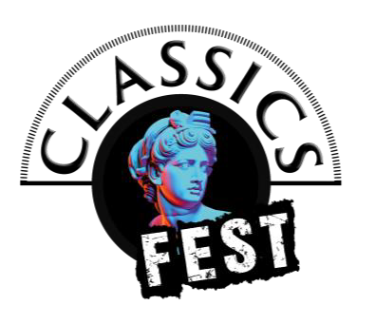

ClassicsFest 2026 Cover Sheet
Please attach this as a separate sheet, to your submission. It will be removed before judging.
Full Name:
Address:
Email:
Mobile Number:

Please Confirm:
- I work, live or study in North East England Yes ☐ No ☐

- I’m available to work with director in March–April 2026? Yes ☐ No ☐

- I’m able to join 2 post-show discussions 14–16 May? Yes ☐ No ☐

